1b

For k=0.1



y* vs 1/kd

x* vs 1/kd

Θ vs 1/kd

For k=10

y* vs 1/kd

x* vs 1/kd

Θ vs 1/kd



syms a x y theta kd k1 k2 k3 k4;

k=10;

kd=[1:0.001:1000];

h=1./kd;

theta=1./(1+kd);

a=(1-(5.*theta));

b=-(1+k)+((1-k).*5.*theta);

c=5.*theta.*k;

x=(-b-sqrt((b.^2)-(4.*a.*c)))./(2.*a);

d=(1-10.*x);

e=-(1+k)+((1-k).*10.*x);

f=10.*x.*k;

y=(-e-sqrt(e.^2-4.*d.*f))./(2.*d);

ylabel('Dimensionless qty');

xlabel('1/kd')

figure(1)

hold on

plot(h,theta,'r');

plot(h,x,'b');

plot(h,y,'g');

grid on;

1c

K=0.1

x* vs 1/kd

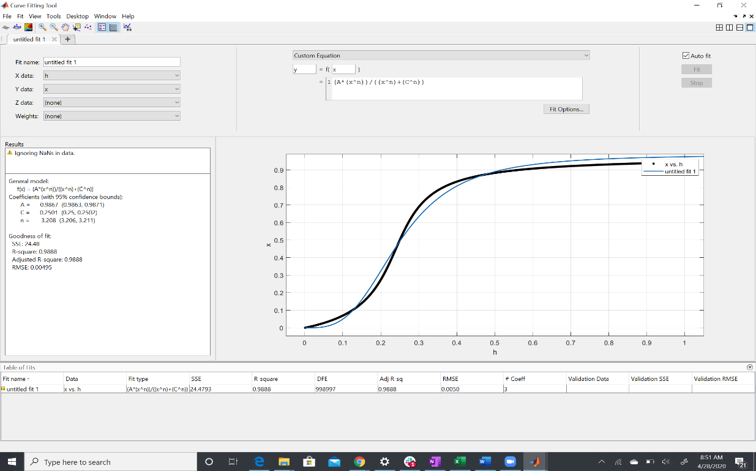

Y* vs 1/kd

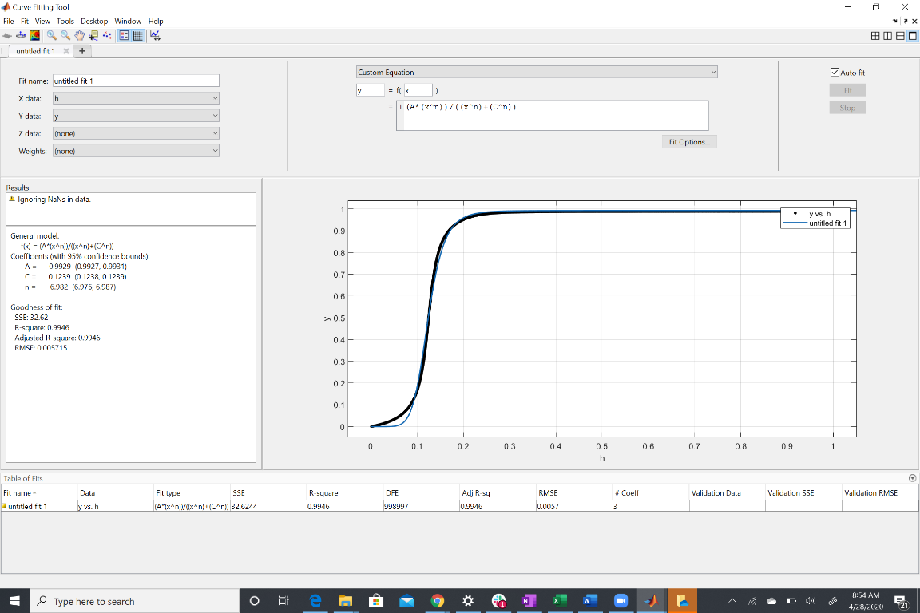

K=10

x* vs 1/kd

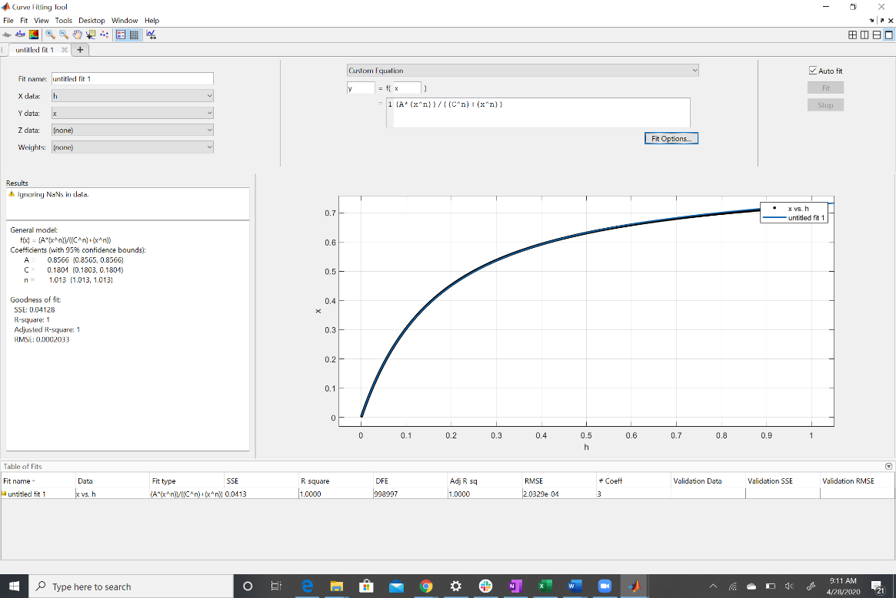

y* vs 1/kd

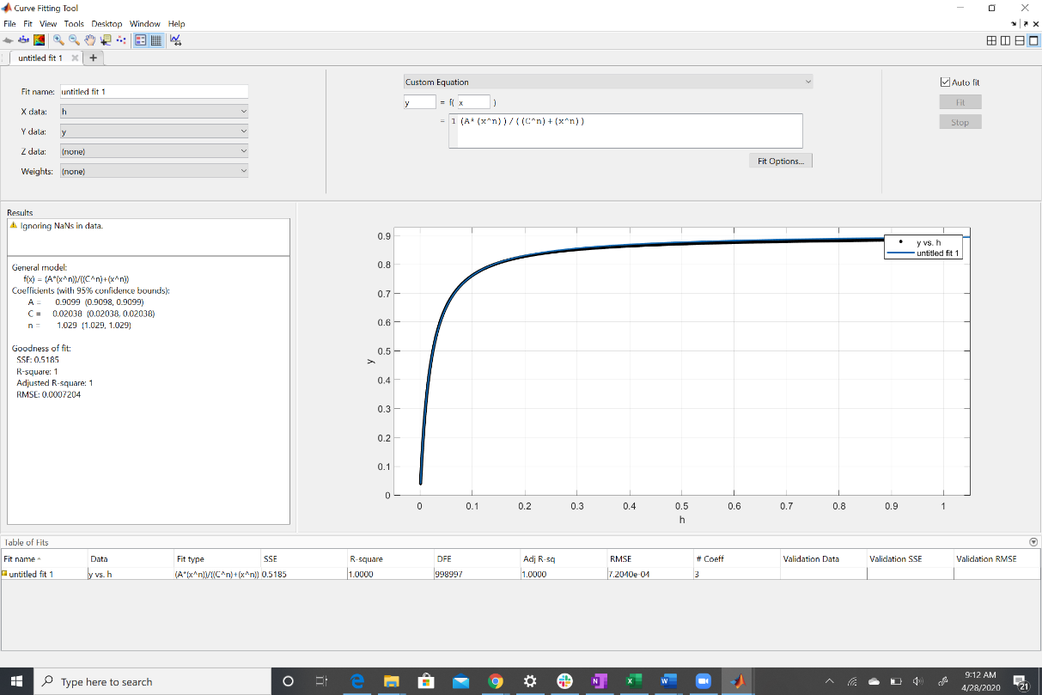

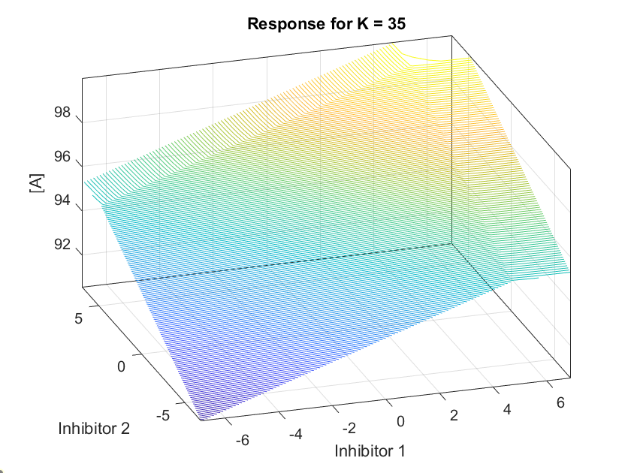

**5**

I1=linspace(0.001,1000,10);

I2=linspace(0.001,1000,10);

l=length(I1); k=35;

A_soln = zeros(length(I1),length(I2));

for i = 1:l

for j = 1:l

i1=I1(i);

i2=I2(j);

eqn= 100==a+( (5*a)./(k*i1 + a.*i1 + k+a))+( (5*a)/(k*i2 + a*i2 + k+a));

A=solve(eqn,a);

A=double(A);

A=A(A>=0);

A_soln(i,j)=A;

j=j+1;

end

i=i+1;

end

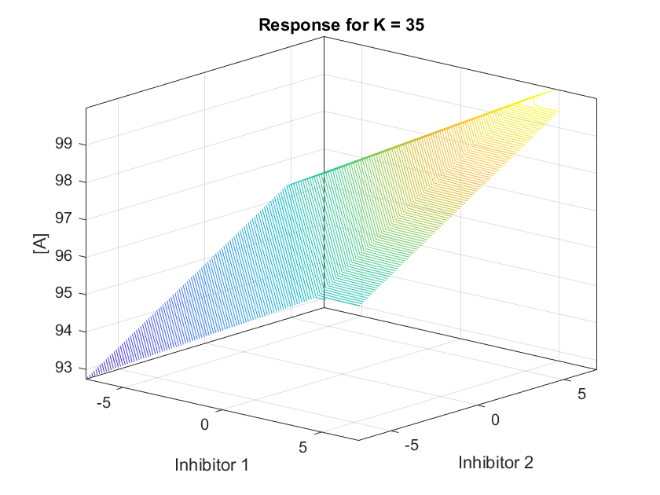

I1=linspace(0.001,1000,10);

I2=linspace(0.001,1000,10);

l=length(I1); k=35;

A_soln = zeros(length(I1),length(I2));

for i = 1:l

for j = 1:l

i1=I1(i);

i2=I2(j);

eqn= 100==a+( (5*a)./(k*i1 + a.*i1 + k+a))+( (5*a)/(k*i2 + a*i2 + k+a));

A=solve(eqn,a);

A=double(A);

A=A(A>=0);

A_soln(i,j)=A;

j=j+1;

end

i=i+1;

end